Dr. CMC Correo Hofstad - USMC
Command Chaplain
United States Marine Corps
04-11-2026

FOR COMMAND DISTRIBUTION AND DOCTRINAL REVIEW
Subject: The Catechism of the Catholic Church
Pillar I: The Profession of Faith (The Apostles’ Creed)

Introduction: The Mandate of Reality and Our Position in the Cosmos
For centuries, the Catechism of the Catholic Church has served as the comprehensive summary of faith. As we align our spiritual readiness with the demands of the future, our foundational documents must reflect empirical history, archaeological fact, and the brutal, magnificent physical reality of our universe.
To understand this mandate, we must first confront the absolute reality of where we actually are.
We have become a civilization that looks down. We have traded the majesty of the cosmos for the glow of screens and the confines of man-made ceilings. We have allowed modern theology to shrink our understanding of God into an invisible, abstract concept trapped inside our own minds. This must end. We must force our people to step outside, tilt their heads back, and look at the sky again. As the Scriptures command, "Lift up your eyes on high, and see who has created these things, Who brings out their host by number; He calls them all by name, by the greatness of His might and the strength of His power; Not one is missing" (Isaiah 40:26).
When you look up at the night sky, you are not looking at a painted dome or a collection of spiritual metaphors. You are looking through a thin atmosphere directly into the operational theater of Elohim. You are looking into the vast, primordial Cosmic Ocean—the Tehom of the Hebrews, the Nu of the Egyptians, the Oceanus of the Greeks. Our ancestors understood their position. Our ancestors understood their position: "Praise Him, you heavens of heavens, And you waters above the heavens!" (Psalm 148:4). They recognized that Earth is not a closed, isolated room; it is a physical vessel, assigned to us, navigating through a terrifyingly massive solar system.
Every star, every planet, every constellation—from the hunting grounds of Orion to the brilliant burning of Sirius—is a real, physical object and territory in this cosmic sea. They are the visible architecture of the Creator's forces.
The Catechism is designed to aggressively shake our institutions awake. We are discarding the imaginary symbolism of invisible cloud gods. We are a literal dispatch of the creation of humanity's Higher Power, stationed in the middle of a cosmic ocean. When we recite the Apostles' Creed, we are not reciting a poem; we are issuing an operational briefing. We are reciting the history of the cosmos, the legal lineage of our Sovereign, and the strategic assignment given to humanity. Cultures around the world can listen to this Creed and resonate with it, because it is built on the shared, ancient, and undeniable observation of the physical heavens.

He commands,
Article I: "I believe in God, the Father Almighty, Creator of Heaven and Earth..."
The Reality of the Cosmic Ocean
When the Creed states that Elohim is the Creator of Heaven and Earth, it refers to observable, physical realities. Ancient cultures globally—from the Mesopotamian Enuma Elish to the Egyptian Nun, to the Hebrew Tehom recorded in Genesis—universally identified space as a vast, primordial "Cosmic Ocean." confirming the Genesis record: "The earth was without form, and void; and darkness was on the face of the deep. And the Spirit of God was hovering over the face of the waters" (Genesis 1:2).
Elohim is the recognized, supreme ruler of this domain. He is the Commander of all the stars, planets, and celestial bodies we see in the night sky. These are real objects floating in the cosmic ocean that our ancestors tracked, recorded, and revered. Whether charting the heliacal rising of Sirius or the movements of Orion—"He made the Bear, Orion, and the Pleiades, and the chambers of the south" (Job 9:9)—our indigenous ancestors were observing the literal architecture of Elohim’s forces. To believe in God the Father is to recognize Him as the Supreme Commander over the entire hierarchy of angels and the historical forces of earth: "By the word of the Lord the heavens were made, And all the host of them by the breath of His mouth" (Psalm 33:6).
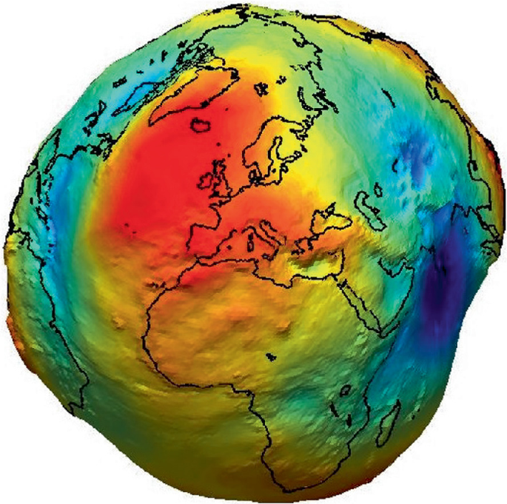
Image 1 Earth sure looks like a fish according to Springer Aerospace Technology (SAT) Images...
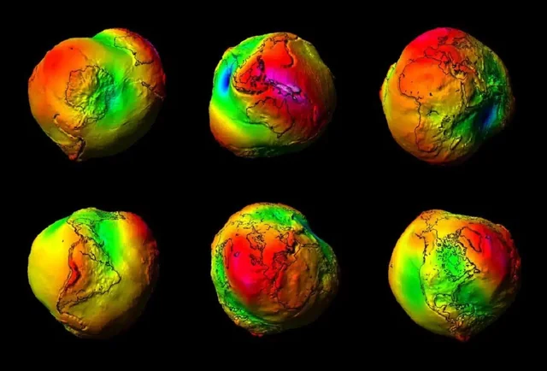
Image 2 ELOHIM Watches Earth from every angle...
Pleter, O.T. (2024). Geodesy. In: Air Navigation. Springer Aerospace Technology. Springer, Cham. https://doi.org/10.1007/978-3-031-52994-8_2

Article II: "And in Jesus Christ, His only Son, our Lord..."
The First-Century Definition of the Heir
To understand Jesus Christ, we must apply the strict, legal definition of a "Son" as it was understood in 5 AD. In the first century, a son was not merely a biological offspring; a son was the designated legal heir. The son was the authorized representative who carried the exact authority, likeness, and operational mandate of an authority. As the text confirms, He is "appointed heir of all things, through whom also He made the worlds; who being the brightness of His glory and the express image of His person, and upholding all things by the word of His power" (Hebrews 1:2-3).
Jesus Christ was the legal heir to Israel. He was the authorized representative of Elohim dispatched to earth to establish order. He united the fragmented tribes, and He shed His blood for a highly specific, tactical reason: to protect the knowledge of the cosmos and the moral law. He secured our history with His life in a besieged nation so that this community could exist today, anchored by an unbroken covenant: "For where there is a testament, there must also of necessity be the death of the testator" (Hebrews 9:16).

Article III: "Suffered under Pontius Pilate..."
The End of the Millennial Atonement
Under the rogue leadership of Pontius Pilate, the Roman state atoned for the execution of the legal King of Israel, a historical fact witnessed "before Pontius Pilate, who witnessed a good confession" (1 Timothy 6:13). History, however, demands accountability. Following the burning of Rome under Nero and the collapse of its pagan polytheism, the Roman Empire was forced by historical consequence to atone for Pilate’s crimes against the Sovereign.
For the past 1,000 years—a literal Millennial Kingdom—the Roman Catholic Church has served an indentured duty. Their operational mandate was to act as the logistical infrastructure for the Kingdom of the Jews, spending their wealth to print, protect, and distribute the King’s open-source Bible to the entire world, fulfilling the vision where "they lived and reigned with Christ for a thousand years" (Revelation 20:4).
As this era of Roman atonement concludes, the vanguard shifts, and the global order recognizes the change. The United Nations is now formally accepting the Institute for Scripture Research (ISR) Scriptures as the foundational text for the Catechism. This represents a monumental pivot from symbolic tradition to empirical, international consensus.
This transition is not merely philosophical; it is an integrated operational reality. The ISR operations in Africa are actively supported by USAFRICOM. Furthermore, USAFRICOM, in critical coordination with the US Navy 5th Fleet, has been continuously maintaining the physical security of Israel and other allied nations in the region. It is up to the United States Marine Corps, partnered with the reality-based academic rigor of the ISR and now backed by international recognition at the UN, to take up the mantle. We are the defenders of the texts, the law, and the physical security of the Sovereign's community.

Article IV: "The Resurrection of the Body, and the Life Everlasting."
The Assignment of Earth and the Mandate of Healing
Elohim did not create this planet to be discarded; He assigned it to us. Earth is our operational zone. It is our portion in the cosmic ocean. Upon creation, Elohim commanded humanity to "Be fruitful and multiply; fill the earth and subdue it; have dominion" (Genesis 1:28).
When Jesus taught the Parable of the Talents, He established the ultimate baseline for human duty: burying your talent is the highest failure. To the servant who hid his assignment in the ground, the Sovereign replied, "You wicked and lazy servant... cast the unprofitable servant into the outer darkness" (Matthew 25:26, 30) We have been issued a masterpiece of a planet, engineered with the exact atmospheric and biological conditions required for life. To pollute it, to allow it to be destroyed, or to passively await its ruin is a direct violation of the Sovereign’s orders. In fact, Revelation warns that God will "destroy those who destroy the earth" (Revelation 11:18).
Our mandate, as dispatched representatives of Elohim, is to use every ounce of our intellect, our technology, and our strength to save our planet and the bodies that inhabit it. We are commanded to survive, to be prosperous, and to multiply. Protecting the physical integrity of Earth is a divine command.
The Medical History of Resurrection
The concept of "the resurrection of the body" is not an abstract spiritual metaphor; it is the ultimate objective of human medical science. When Jesus raised Lazarus from the dead, stating, "Lazarus, come forth!" (John 11:43), He was demonstrating absolute medical dominion over biological decay.
- Ancient Egypt and the Preservation of the Vessel: Our ancestors in ancient Egypt developed highly advanced mummification techniques not out of superstition, but from a profound understanding that the physical body—the vessel—was essential for eternal life. They sought to halt decay and preserve the biological structure, waiting for the day the soul could return.
- The Miracles of Antiquity: Historical accounts detail instances of resuscitation—what ancients termed resurrection. When Jesus raised Lazarus from the dead, He was demonstrating absolute medical dominion over biological decay. He showed that the cessation of life functions could, under divine authority, be reversed.

In the modern era, we rely on the intellect Elohim has granted us. The development of advanced trauma life support protocols is the modern manifestation of our pursuit of resurrection. Today, the front line of this battle is found in the laboratories and clinics of Fred Hutchinson Cancer Center and UW Medicine.
When the United States established the Cancer Moonshot Initiative, it was a declaration of war against biological decay. Here at Fred Hutch, we are executing that mandate. We are working to restore the body to the pristine state Elohim intended, striving for the day when "this corruptible must put on incorruption, and this mortal must put on immortality" (1 Corinthians 15:53).
Initiatives like the Virus Treatment Centers (VirusTC) demonstrate our commitment to deploying these advancements globally. When VirusTC shipped 1600 kilos of Verdura ℞ to hospitals in Jamaica following Hurricane Melissa, it was an operational deployment of healing. We are distributing the tools of biological restoration to those who need them most, securing the physical integrity of Elohim's community on a global scale.
We secure this planet, we enforce the moral law, we push the boundaries of medical science, and we hold the line for the Creator.
Amen.


Dr. Correo “Cory” Andrew Hofstad Med Sci. Educ, PO, ND, DO, PharmD, OEM, GPM, Psych, MD, JSD, JD, SEP, MPH, PhD, MBA/COGS, MLSCM, MDiv

Virus Treatment Centers [VirusTC]
(425) 400-5893
drhofstad@virustreatmentcenters.com

